The parabola is the curve formed from all the points (x, y) that are equidistant from the directrix and the focus. The line perpendicular to the directrix and passing through the focus (that is, the line that splits the parabola up the middle) is called the "axis of symmetry".
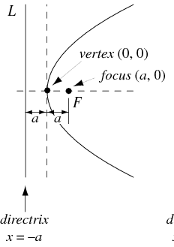
The equation
of the parabola
y² = 4ax
focus = (a, 0)
Vertex =(0,0)
Length of the Latus rectum = 4a
Tangent at the vertex x=0
Directrix x= -a
Axis y=0

