Certain public areas such as parks have litter bins which are placed alongside paths frequently walked by visitors. This encourages people to avoid littering, which creates an unhealthy and aesthetically unpleasant social environment. Public trash bins may be accompanied by recycling bins or "bottle bins" to be used for recycling glass and plastic. Some public bins, especially in "green" restaurants, accept organic waste to be composted.
Bins in outdoor locations or other busy public areas are usually mounted to the ground or wall. This discourages theft, and also reduces vandalism by making it harder for someone to physically move or maneuver the bins; to spill their contents on the ground for example, or to use the bin as an effective weapon to hit people over the back with.
In the past terrorists have left improvised explosive devices in bins. The bomb is much less likely to be spotted than an unattended bag and the metal bins provide extra shrapnelthat injures people nearby when it detonates. For this reason there are no bins in most railway stations, most airports, and many shopping centres in the United Kingdom, or if they are provided they are just a bin bag hanging from a metal loop.^{[citation needed]} The Bay Area Rapid Transit system in northern California also removed trash cans to prevent bombs from being hidden in them.^{[1]}
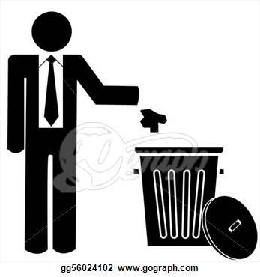
A Danish design company called Peoples ApS, have in cooperation with Swedish based Dynasafe AB, developed a "bombproof" bin suitable for public places. The bins were successfully tested at Saab Bofors test center, an independent third party, using the maximum amount of explosives^{[which?]} specified for the particular design.^{[citation needed]} Shortly after the 2004 Madrid train bombings, the Massachusetts Bay Transportation Authority used about $500,000 in grant money from the federal United States government to purchase $2,000 bomb-proof trash cans manufactured by the Mistral Group, meant to direct the explosion upward. MBTA testing found the cans failed to contain an explosion using only 20% of the amount of explosive used in Madrid, depending on placement.^{[2]} Apartment buildings often have two dust flumes in which residents can dispose of their trash in stainless steel trash cans.^{[3]} These chutes usually lead to some large receptacle or trash complex in the basement.

