Let n be the unknown number, then:
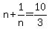 Multiply both sides by n.
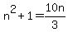 Multiply both sides by 3.
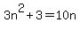 Subtract 10n from both sides.
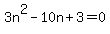 Solve this quadratic equation by factoring.
Apply the zero product principle.
If , then , and 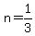 or
If , then
The two numbers are: 3 and 1/3 .

