.
.

NTPC Faridabad Training Report
Ratings: (3)|Views: 25,082|Likes: 314
Published by api-3696235
See More

ACKNOWLEDGEMENTS
I would firstly wish to thank
Mrs. …………………………….
for allowing me toundergo summer training at NTPC Faridabad , all of the HR team of the Institutefor their continued guidance. I would also wish to convey my warm regards to
Mr.………..
and
Mr. ……………..
for providing me with all the knowledge databasethat I needed for this report.I would also like to thank Mr. ……………… , TPO – …………………….…………, for providing me this wonderful opportunity to work with the NTPCfamily

ABOUT THE COMPANY
Corporate Vision:
“A world class integrated power major, powering India’s growth, with increasing global presence”
Core Values:
B-
Business Ethics
C-
Customer Focus
O-
Organizational & Professional pride
M-
Mutual Respect and Trust
I-
Innovation & Speed
T-
Total quality for Excellence NTPC Limited is the largest thermal power generating company of India. A public sector company, it was incorporated in the year 1975 to accelerate power development in the country asa wholly owned company of the Government of India. At present, Government of India holds89.5% of the total equity shares of the company and the balance 10.5% is held by FIIs, DomesticBanks, Public and others. Within a span of 31 years, NTPC has emerged as a truly national power company, with power generating facilities in all the major regions of the country.
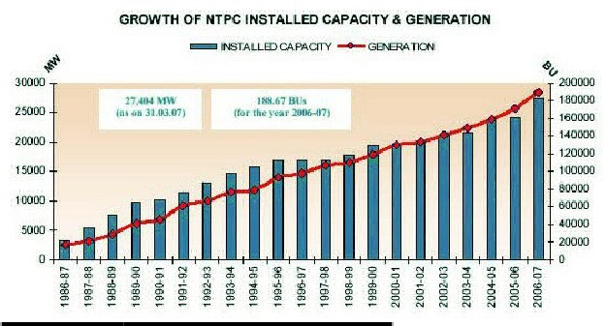
If u want to read go on these
http://www.scribd.com/doc/6542298/NTPCt-Faridabad-Training-Repor

