[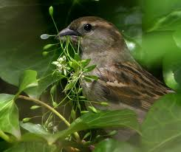](http://www.google.co.in/imgres?imgurl=http://people.eku.edu/ritchisong/sparrownestmaterial.jpg&imgrefurl=http://people.eku.edu/ritchisong/birdnests.html&h=590&w=700&tbnid=tV0H6eaMaaY8nM:&zoom=1&docid=xzc-NQzPXyur5M&ei=fKyiU97HGcecugS6jYLgAw&tbm=isch&ved=0CCQQMygKMAo)

[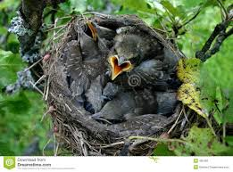](http://www.google.co.in/imgres?imgurl=http://thumbs.dreamstime.com/z/baby-birds-their-nest-495493.jpg&imgrefurl=http://www.dreamstime.com/stock-photos-baby-birds-their-nest-image495493&h=960&w=1300&tbnid=_OsrkfcgEB8xRM:&zoom=1&docid=sYI6UJprogmysM&ei=fKyiU97HGcecugS6jYLgAw&tbm=isch&ved=0CCUQMygLMAs)

[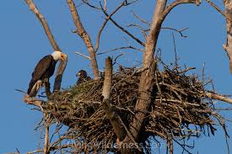](http://www.google.co.in/imgres?imgurl=http://cdn.c.photoshelter.com/img-get/I0000r6lq95SLA_Q/s/750/750/BaldEagle-ParentAndChick-Nest-Puyallup-0378.jpg&imgrefurl=http://livingwilderness.photoshelter.com/image/I0000r6lq95SLA_Q&h=500&w=750&tbnid=reW0fWSvd9kL7M:&zoom=1&docid=ufaevRZH3HHsfM&ei=fKyiU97HGcecugS6jYLgAw&tbm=isch&ved=0CCYQMygMMAw)

[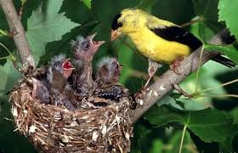](http://www.google.co.in/imgres?imgurl=http://3.bp.blogspot.com/-SCdGujBxqsw/UgvxpXXHWpI/AAAAAAAAKVE/sXQLszcoHhg/s1600/goldfinch%252Bamerican%252Byellow%252Bbird%252Bnesting%252Bbaby%252Bfeeding%252Bmale%252Bblack%252Bcap.jpg&imgrefurl=http://lansingwbu.blogspot.com/2013/08/watch-and-listen-for-baby-goldfinches.html&h=315&w=489&tbnid=SpGXLA3qCJHZxM:&zoom=1&docid=UClD0TBwg8-hRM&ei=fKyiU97HGcecugS6jYLgAw&tbm=isch&ved=0CCcQMygNMA0)

[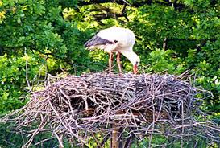](http://www.google.co.in/imgres?imgurl=http://www.denhaag.nl/upload/e9840786-fc34-4bca-8b6a-36c4fb117435_Stork-in-nest.jpg&imgrefurl=http://www.denhaag.nl/en/residents/nature-and-environment/to/No-bread-for-storks-and-other-birds.htm&h=270&w=400&tbnid=Ei0rbH1fX1gaRM:&zoom=1&docid=M2ZZIpYZ5HcZKM&ei=fKyiU97HGcecugS6jYLgAw&tbm=isch&ved=0CCgQMygOMA4)

[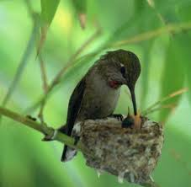](http://www.google.co.in/imgres?imgurl=http://2.bp.blogspot.com/-RwT4zc14AU0/TaThtNqrVmI/AAAAAAAAAJw/MkCloKLqaPY/s1600/5.jpg&imgrefurl=http://vaishnavipj.blogspot.com/2011/04/lesson-in-preservance.html&h=686&w=700&tbnid=ov75wxF5d6w86M:&zoom=1&docid=aphvx551Ut7I9M&ei=fKyiU97HGcecugS6jYLgAw&tbm=isch&ved=0CCkQMygPMA8)

[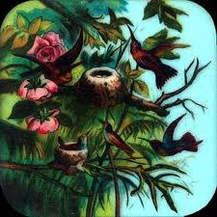](http://www.google.co.in/imgres?imgurl=http://a-day-in-the-life.powys.org.uk/images/u_primus723-1.jpg&imgrefurl=http://a-day-in-the-life.powys.org.uk/eng/cult/magiclan/eu_723.php&h=322&w=322&tbnid=q7R0zIF6qAH3AM:&zoom=1&docid=Zei6-V7qlX8VhM&ei=fKyiU97HGcecugS6jYLgAw&tbm=isch&ved=0CCoQMygQMBA)

[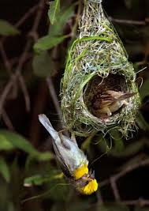](http://www.google.co.in/imgres?imgurl=http://www.thehindu.com/multimedia/dynamic/00358/16bgdpkPhotoexhibit_358462e.jpg&imgrefurl=http://www.thehindu.com/todays-paper/tp-national/tp-karnataka/weaving-family-photos-of-a-different-kind/article1096346.ece&h=449&w=318&tbnid=GoewE9BQepQBUM:&zoom=1&docid=nzbOdNDy_uR-VM&ei=fKyiU97HGcecugS6jYLgAw&tbm=isch&ved=0CCsQMygRMBE)

[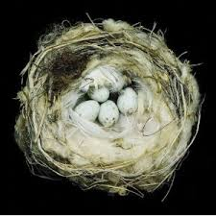](http://www.google.co.in/imgres?imgurl=http://ecx.images-amazon.com/images/I/51d0K7n0dlL._SL500_AA300_.jpg&imgrefurl=http://www.brainpickings.org/index.php/2011/03/29/sharon-beals-nests/&h=300&w=300&tbnid=mVDo9ZO5hJVniM:&zoom=1&docid=SdxKGjkRATw66M&ei=fKyiU97HGcecugS6jYLgAw&tbm=isch&ved=0CCwQMygSMBI)

[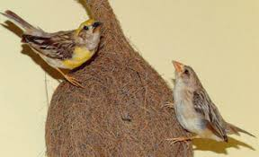](http://www.google.co.in/imgres?imgurl=http://www.nhm.ac.uk/resources-rx/images/1007/baya-weaver-nest-slide_13778_1.jpg&imgrefurl=http://www.nhm.ac.uk/visit-us/galleries/green-zone/birds/&h=225&w=370&tbnid=BdWAOn5sMXfL9M:&zoom=1&docid=Tewvmgu_sjTa_M&ei=fKyiU97HGcecugS6jYLgAw&tbm=isch&ved=0CC0QMygTMBM)

[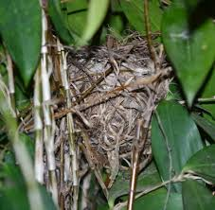](http://www.google.co.in/imgres?imgurl=http://photos1.blogger.com/blogger/7143/1346/400/bbb.6.jpg&imgrefurl=http://besgroup.blogspot.com/2006/11/do-birds-recycle-their-nests.html&h=390&w=400&tbnid=sj3xZi5Ncfcd4M:&zoom=1&docid=tjvHYwh5_QWFJM&ei=fKyiU97HGcecugS6jYLgAw&tbm=isch&ved=0CDcQMygUMBQ)

[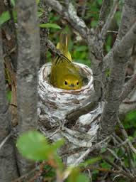](http://www.google.co.in/imgres?imgurl=http://opinicon.files.wordpress.com/2010/01/female_yellowwarbler.jpg&imgrefurl=http://opinicon.wordpress.com/2010/01/19/coping-with-cowbirds-yellow-warblers-stack-nest/&h=320&w=240&tbnid=FPsnKZEAXu_9PM:&zoom=1&docid=XhJgiLznzvxNgM&ei=fKyiU97HGcecugS6jYLgAw&tbm=isch&ved=0CDgQMygVMBU)

[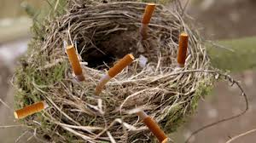](http://www.google.co.in/imgres?imgurl=http://doubtfulnewscom.c.presscdn.com/wp-content/uploads/2014/03/bird-nest.jpg&imgrefurl=http://doubtfulnews.com/2014/03/fire-likely-caused-by-bird-using-lit-cigarette-in-nest/&h=225&w=400&tbnid=DtX4B8aas5KC2M:&zoom=1&docid=TnTtbBoJ_X5FbM&ei=fKyiU97HGcecugS6jYLgAw&tbm=isch&ved=0CDkQMygWMBY)

[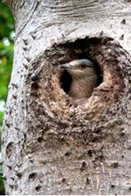](http://www.google.co.in/imgres?imgurl=http://3.bp.blogspot.com/-1hyr3sAiwTk/UJIaOnJXtHI/AAAAAAAAAUE/ItTO5iG6Lhc/s1600/Hole%252Bnest.jpg&imgrefurl=http://wavesbp.blogspot.com/&h=900&w=600&tbnid=3HScJ1wgaPF1gM:&zoom=1&docid=55JvZu9ogJLmDM&ei=fKyiU97HGcecugS6jYLgAw&tbm=isch&ved=0CDoQMygXMBc)

[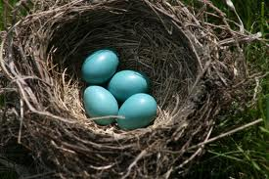](http://www.google.co.in/imgres?imgurl=http://northshorekid.com/sites/default/files/imagecache/post_photo/events/birds_nest.jpg&imgrefurl=http://northshorekid.com/event/eco-art-bird-nests&h=383&w=575&tbnid=oJALRDN91UZM7M:&zoom=1&docid=XWGUg2M7MaSafM&ei=fKyiU97HGcecugS6jYLgAw&tbm=isch&ved=0CDsQMygYMBg)

[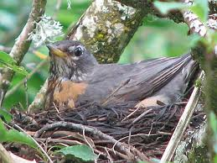](http://www.google.co.in/imgres?imgurl=http://4.bp.blogspot.com/_N9wtKAb3vvc/SG2wvw6tycI/AAAAAAAACmw/ZomcH5SBwv8/s1600/Close%252Bup%252Bbird%252Bin%252Bnest.jpg&imgrefurl=http://www.nickweaver.co.uk/services/protected-species/nesting-birds&h=375&w=500&tbnid=v7ti_aKg9bCLVM:&zoom=1&docid=xzYtmhzGeWqOAM&ei=fKyiU97HGcecugS6jYLgAw&tbm=isch&ved=0CDwQMygZMBk)

[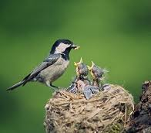](http://www.google.co.in/imgres?imgurl=http://cdn3.kidsdiscover.com/wp-content/uploads/2012/05/Christy-Peterson-Parents-2.jpg&imgrefurl=http://www.kidsdiscover.com/parentresources/backyard-science-for-kids/&h=215&w=245&tbnid=Wn_Nscvhs1nudM:&zoom=1&docid=L6bp03rLQBH9rM&ei=fKyiU97HGcecugS6jYLgAw&tbm=isch&ved=0CD0QMygaMBo)

[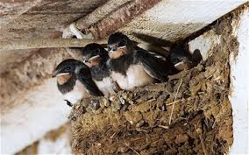](http://www.google.co.in/imgres?imgurl=http://i.telegraph.co.uk/multimedia/archive/01896/nest_1896575c.jpg&imgrefurl=http://www.telegraph.co.uk/earth/wildlife/8515914/Dry-weather-leaves-birds-with-no-mud-for-nests-says-RSPB.html&h=287&w=460&tbnid=aIrhOFc8XymApM:&zoom=1&docid=Ym6bHGkmZOT1sM&ei=fKyiU97HGcecugS6jYLgAw&tbm=isch&ved=0CD4QMygbMBs)

[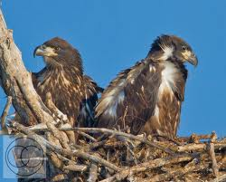](http://www.google.co.in/imgres?imgurl=http://gallery.exoticwildlifephotos.com/img/s1/v20/p138204994-3.jpg&imgrefurl=http://gallery.exoticwildlifephotos.com/florida-birds/h83CD742&h=450&w=559&tbnid=KXPkKLw-LVtdPM:&zoom=1&docid=5UyCUKi1_s0wZM&ei=fKyiU97HGcecugS6jYLgAw&tbm=isch&ved=0CD8QMygcMBw)

[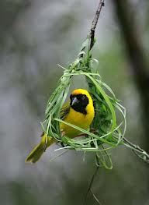](http://www.google.co.in/imgres?imgurl=http://3.bp.blogspot.com/-_zdsiqKKU9M/TjgrixWAPyI/AAAAAAAAATM/7xQaaFZCOMQ/s1600/Beautiful-birds-nests-photo-pictures-wallpapers-images-3.jpg&imgrefurl=http://ajabgajabphotos.blogspot.com/2011/08/birds-nests-photos-pictures-wallpapers.html&h=548&w=400&tbnid=oVRCDjPuVGGF1M:&zoom=1&docid=_8wFhGwe_Ypq3M&ei=fKyiU97HGcecugS6jYLgAw&tbm=isch&ved=0CEAQMygdMB0)

[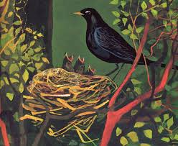](http://www.google.co.in/imgres?imgurl=http://4.bp.blogspot.com/-B7G2hLsCX74/TeBEGUX4gzI/AAAAAAAABJE/Xa-t2_Pi-1s/s1600/img459.jpg&imgrefurl=http://googoogallerykids.blogspot.com/2011_05_01_archive.html&h=1308&w=1600&tbnid=c2p8acJ7WIOU-M:&zoom=1&docid=S6wm8y0jxKeF2M&ei=fKyiU97HGcecugS6jYLgAw&tbm=isch&ved=0CEEQMygeMB4)

[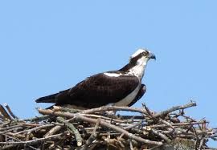](http://www.google.co.in/imgres?imgurl=http://3.bp.blogspot.com/-p0qQs2-HphA/UXxvQTZ9f2I/AAAAAAAABpc/AfsT7yejmx0/s1600/IMG_4457.JPG&imgrefurl=http://travelswithbirds.blogspot.com/2013/04/western-osprey-pandion-haliaetus-27.html&h=1109&w=1600&tbnid=YL8R7wR-NhJCPM:&zoom=1&docid=1mKnEzbeW8YdaM&ei=fKyiU97HGcecugS6jYLgAw&tbm=isch&ved=0CEIQMygfMB8)

[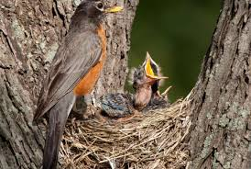](http://www.google.co.in/imgres?imgurl=http://youthfocusedpolicing.com/wp-content/uploads/2014/04/Baby-Birds-Fall-Out.jpg&imgrefurl=http://youthfocusedpolicing.com/why-do-little-one-birds-fall-out-of-their-nests.html&h=430&w=640&tbnid=GggXDp4a6UR7WM:&zoom=1&docid=wAVjzsWF4yWEaM&ei=fKyiU97HGcecugS6jYLgAw&tbm=isch&ved=0CEMQMyggMCA)

[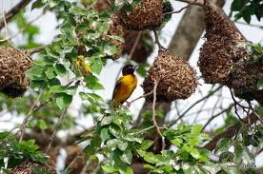](http://www.google.co.in/imgres?imgurl=http://2.bp.blogspot.com/-0jOU-oQxzlo/TcKUenvjXVI/AAAAAAAACZY/xlorXTsmVzY/s1600/IMGP9108.JPG&imgrefurl=http://juzaringhana.blogspot.com/2011/05/weaver-birds.html&h=425&w=640&tbnid=ydgYDcVrwLbVCM:&zoom=1&docid=Oxm-sKsDsvGdWM&ei=fKyiU97HGcecugS6jYLgAw&tbm=isch&ved=0CEQQMyghMCE)

[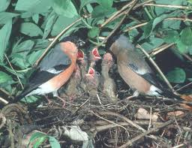](http://www.google.co.in/imgres?imgurl=http://www.welshicons.org.uk/news/wp-content/uploads/2012/03/Bullfinches-8.5x6.5.jpg&imgrefurl=http://www.welshicons.org.uk/news/nesting-birds-and-their-protection-dont-fall-fowl-of-the-law/&h=307&w=400&tbnid=5dHF4gWr-cjdUM:&zoom=1&docid=hsElTWMT5sYnWM&ei=fKyiU97HGcecugS6jYLgAw&tbm=isch&ved=0CEUQMygiMCI)

[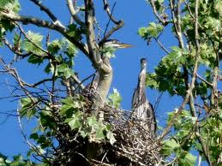](http://www.google.co.in/imgres?imgurl=http://sally1029.files.wordpress.com/2012/04/herons-on-nest.jpg&imgrefurl=http://sally1029.wordpress.com/2012/04/04/heron-nesting-means-spring/&h=2592&w=3456&tbnid=_vf8V6_ZY_fPjM:&zoom=1&docid=ROPxuc98iOHzxM&ei=fKyiU97HGcecugS6jYLgAw&tbm=isch&ved=0CEYQMygjMCM)

[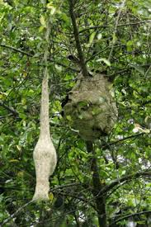](http://www.google.co.in/imgres?imgurl=http://besgroup.org/wp-content/uploads/2007/06/bayaweaver-vespa-affinischanyokemeng-2-copy.jpg&imgrefurl=http://www.besgroup.org/2007/06/28/baya-weaver-hornets/&h=400&w=266&tbnid=ldtRcg2wqiBiOM:&zoom=1&docid=995UmcCNmYf7TM&ei=fKyiU97HGcecugS6jYLgAw&tbm=isch&ved=0CEcQMygkMCQ)

[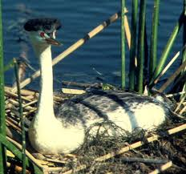](http://www.google.co.in/imgres?imgurl=http://upload.wikimedia.org/wikipedia/commons/a/a3/Aechmophorus_clarkii_on_nest.jpg&imgrefurl=http://www.bukisa.com/articles/38554_amazingly-unique-nesting-mating-and-hatching-behavior-of-birds&h=473&w=507&tbnid=GbpPesgDKy-07M:&zoom=1&docid=MENhKws4hNjfiM&ei=fKyiU97HGcecugS6jYLgAw&tbm=isch&ved=0CEgQMyglMCU)

[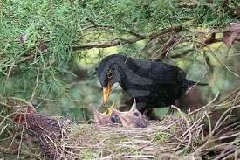](http://www.google.co.in/imgres?imgurl=http://www.cleulow.com/mediac/400_0/media/a-blackbird-feeding-little-birds-in-their-nest.jpg&imgrefurl=http://www.cleulow.com/24962/44103.html&h=266&w=400&tbnid=Bir-CBlowNggkM:&zoom=1&docid=ShAOvrb5xmk1PM&ei=fKyiU97HGcecugS6jYLgAw&tbm=isch&ved=0CEkQMygmMCY)

[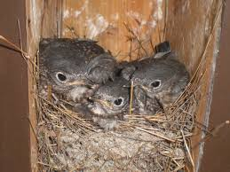](http://www.google.co.in/imgres?imgurl=http://1.bp.blogspot.com/_a-i8d_Mh3BQ/S8hxqYNdqtI/AAAAAAAAAMk/qTbcRtEI2nw/s1600/ANBS3.JPG&imgrefurl=http://world-bird-sanctuary.blogspot.com/2010/04/migration-blitz.html&h=1024&w=1366&tbnid=plTElALcsejQ9M:&zoom=1&docid=b-7Uudg1Nb5X3M&ei=fKyiU97HGcecugS6jYLgAw&tbm=isch&ved=0CEoQMygnMCc)

[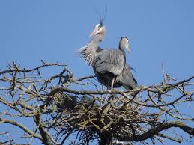](http://www.google.co.in/imgres?imgurl=http://1.bp.blogspot.com/-cSPVCZWWV58/UWRRkO9B1yI/AAAAAAAABTU/EEZ57fty2Es/s1600/Great%252BBlue%252BHeron%252BSX2242.jpg&imgrefurl=http://slatermuseum.blogspot.com/2013/04/a-heronry-to-watch.html&h=900&w=1200&tbnid=3epuTK-cfIphsM:&zoom=1&docid=IekskVSQCIxQZM&ei=fKyiU97HGcecugS6jYLgAw&tbm=isch&ved=0CEsQMygoMCg)

[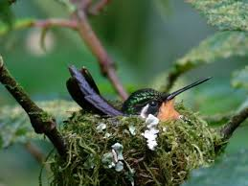](http://www.google.co.in/imgres?imgurl=http://2.bp.blogspot.com/-8C8MepX093A/T4Xn1kPQtmI/AAAAAAAABHg/akRkLK5zBH8/s1600/Purple-throated%252BMountain-gem,%252Bfemale%252Bon%252Bnest%252B600.jpg&imgrefurl=http://rududu-carolina.blogspot.com/2012/04/home-sweet-home.html&h=450&w=600&tbnid=SoP_GS_E12pMNM:&zoom=1&docid=xJJawKSQArE5cM&ei=fKyiU97HGcecugS6jYLgAw&tbm=isch&ved=0CEwQMygpMCk)

[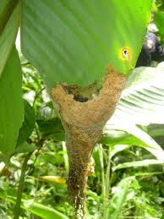](http://www.google.co.in/imgres?imgurl=http://www.traveljournals.net/pictures/l/17/172190-little-birds-in-their-nest-puerto-auxillio-peru.jpg&imgrefurl=http://www.traveljournals.net/pictures/172190.html&h=640&w=480&tbnid=gNG05PM6wJgGlM:&zoom=1&docid=dIKlAPuL6z3ANM&ei=fKyiU97HGcecugS6jYLgAw&tbm=isch&ved=0CE0QMygqMCo)

[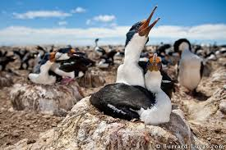](http://www.google.co.in/imgres?imgurl=http://img.burrard-lucas.com/falklands/normal/imperial_shags.jpg&imgrefurl=http://blog.burrard-lucas.com/2010/01/nesting-shags-varying-the-perspective/&h=399&w=600&tbnid=DLpup9r5EB2p-M:&zoom=1&docid=ldLyb1PK2SfsUM&ei=fKyiU97HGcecugS6jYLgAw&tbm=isch&ved=0CE4QMygrMCs)

[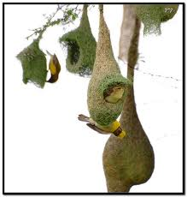](http://www.google.co.in/imgres?imgurl=https://yy1.staticflickr.com/4109/4958682759_d225d36971.jpg&imgrefurl=https://www.flickr.com/photos/yogendra174/4958682759/&h=500&w=475&tbnid=lDjgR59_HU_3TM:&zoom=1&docid=Cosqu_TXb7q6XM&ei=fKyiU97HGcecugS6jYLgAw&tbm=isch&ved=0CE8QMygsMCw)

[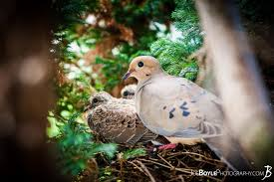](http://www.google.co.in/imgres?imgurl=http://www.joeboylephotography.com/virteom/uploaded_media/Modules/Categories/xx-large/201303001-1600-birds-in-nest-1363289773.jpg&imgrefurl=http://www.joeboylephotography.com/animals-insects/photo/birds-in-nest/315&h=1060&w=1590&tbnid=jBzur_c6bfX5fM:&zoom=1&docid=gGLMgvjB-NtN-M&ei=fKyiU97HGcecugS6jYLgAw&tbm=isch&ved=0CFAQMygtMC0)

[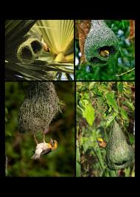](http://www.google.co.in/imgres?imgurl=http://3.bp.blogspot.com/-II25P6bzjOY/T9WxBurEGbI/AAAAAAAAABo/4OuLlKBK8us/s1600/picture%252Bnice.jpg&imgrefurl=http://beautysecn.blogspot.com/&h=1050&w=750&tbnid=vqLWTkKvPWgWKM:&zoom=1&docid=o09oxW8wJZWALM&ei=fKyiU97HGcecugS6jYLgAw&tbm=isch&ved=0CFEQMyguMC4)

[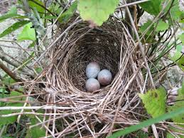](http://www.google.co.in/imgres?imgurl=http://1.bp.blogspot.com/-ERHJNSo_s-E/ThuUD8GwggI/AAAAAAAAJv4/pHOlkpqr8Vc/s1600/1.jpg&imgrefurl=http://bluejaybarrens.blogspot.com/2011/07/field-sparrow-nest.html&h=1200&w=1600&tbnid=aJWtzQQylrFW2M:&zoom=1&docid=e2ab4N2LO0QHSM&ei=fKyiU97HGcecugS6jYLgAw&tbm=isch&ved=0CFIQMygvMC8)

[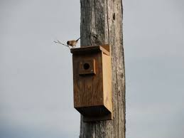](http://www.google.co.in/imgres?imgurl=http://northforkbandb.files.wordpress.com/2011/07/birds-and-their-nests-002-600.jpg&imgrefurl=http://northforkbandb.wordpress.com/2011/07/01/530/&h=450&w=600&tbnid=0y-IUXj5iJ-qGM:&zoom=1&docid=4P8unKMeASVtWM&ei=fKyiU97HGcecugS6jYLgAw&tbm=isch&ved=0CFMQMygwMDA)

[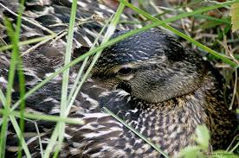](http://www.google.co.in/imgres?imgurl=http://images.quickblogcast.com/4/3/6/4/3/143794-134634/FemaleMallardonnest.jpg%253Fa%253D75&imgrefurl=http://wildnewjersey.tv/2011/05/12/natures-focus-birds-and-their-nesting-habits.aspx&h=680&w=1024&tbnid=NS982GBl6VHBwM:&zoom=1&docid=qzGqPikS9L7doM&ei=fKyiU97HGcecugS6jYLgAw&tbm=isch&ved=0CFQQMygxMDE)

[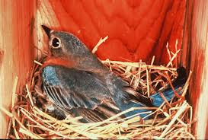](http://www.google.co.in/imgres?imgurl=http://www.backyardbirdlover.com/wp-content/uploads/2012/06/Female-on-nest.jpg&imgrefurl=http://www.backyardbirdlover.com/tag/nesting-birds/&h=518&w=768&tbnid=Wt8XuWuBgKynSM:&zoom=1&docid=ktIjNQZzSQX_kM&ei=fKyiU97HGcecugS6jYLgAw&tbm=isch&ved=0CFUQMygyMDI)

[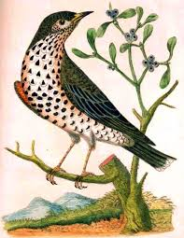](http://www.google.co.in/imgres?imgurl=http://4.bp.blogspot.com/-9NYBFh0sgMw/Tk53mm_p3fI/AAAAAAAAAdI/qFX8v-j9NeU/s1600/mistlethrush_520.jpg&imgrefurl=http://chethamslibrary.blogspot.com/2011/08/birds-and-their-nests.html&h=672&w=520&tbnid=b3qBATnbEGHGwM:&zoom=1&docid=3Rz6MPgowAgeDM&ei=fKyiU97HGcecugS6jYLgAw&tbm=isch&ved=0CFYQMygzMDM)

[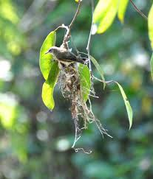](http://www.google.co.in/imgres?imgurl=http://swampythings.files.wordpress.com/2011/10/ww20111002_wild_wings_swampy_things_birds_large-billed-gerygone_nest-building1.jpg&imgrefurl=http://wildwings.com.au/2011/10/08/nesting-activity/&h=1536&w=1312&tbnid=7qFED4au5znKOM:&zoom=1&docid=SwQvFdb2nfguHM&ei=fKyiU97HGcecugS6jYLgAw&tbm=isch&ved=0CFcQMyg0MDQ)

[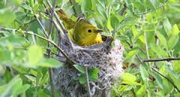](http://www.google.co.in/imgres?imgurl=http://www.ec.gc.ca/paom-itmb/C51C415F-AC8B-4974-9E21-F51884FF7374/0011-YW.jpg&imgrefurl=http://www.ec.gc.ca/paom-itmb/&h=162&w=300&tbnid=L2eFJqEBXMhWiM:&zoom=1&docid=GfoFAVXyFYNdiM&ei=fKyiU97HGcecugS6jYLgAw&tbm=isch&ved=0CFgQMyg1MDU)

[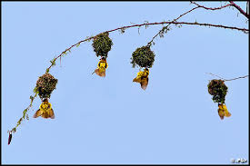](http://www.google.co.in/imgres?imgurl=https://c1.staticflickr.com/1/110/316393412_b4c4097b50.jpg&imgrefurl=https://www.flickr.com/photos/pg-photography/316393412/&h=334&w=500&tbnid=cX8LnTXb8gu8MM:&zoom=1&docid=8-Pn5kWOCkhawM&ei=fKyiU97HGcecugS6jYLgAw&tbm=isch&ved=0CFkQMyg2MDY)

[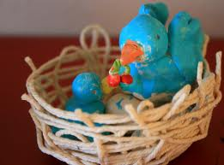](http://www.google.co.in/imgres?imgurl=http://4.bp.blogspot.com/-iW_IYYoXSuI/TY_0hjioV4I/AAAAAAAAEFU/sICJj-qGQBg/s1600/birds-nests-11.jpg&imgrefurl=http://chocolateonmycranium.blogspot.com/2011/03/making-birds-nests.html&h=1188&w=1600&tbnid=2dvMrAHUfndr1M:&zoom=1&docid=BI3RCDEAHdn4XM&ei=fKyiU97HGcecugS6jYLgAw&tbm=isch&ved=0CFoQMyg3MDc)

[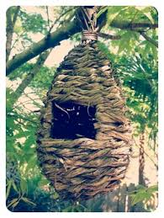](http://www.google.co.in/imgres?imgurl=http://www.ohkissa.com/uploads/3/1/6/4/3164351/4252398.jpg%253F251&imgrefurl=http://www.ohkissa.com/thought-bubble/helping-the-little-birds-with-their-nests&h=334&w=251&tbnid=DF2m02ugtKl0hM:&zoom=1&docid=4-YngDZrSHm7dM&ei=fKyiU97HGcecugS6jYLgAw&tbm=isch&ved=0CFsQMyg4MDg)

[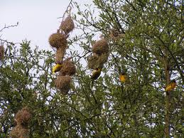](http://www.google.co.in/imgres?imgurl=http://www.travelphotosforyou.com/albums/tanzania/the-serengeti-national-park/africa_tanzania_serengeti_birds_with_nest.jpg&imgrefurl=http://www.travelphotosforyou.com/tanzania/the-serengeti-national-park/africa_tanzania_serengeti_birds_building_nest&h=420&w=560&tbnid=nydfpvs0bWFX1M:&zoom=1&docid=rd2xHBzVtDG1JM&ei=fKyiU97HGcecugS6jYLgAw&tbm=isch&ved=0CFwQMyg5MDk)

[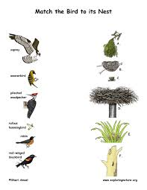](http://www.google.co.in/imgres?imgurl=http://www.exploringnature.org/graphics/teaching_aids/bird_nest_matching_text72.jpg&imgrefurl=http://www.exploringnature.org/db/detail.php?dbID%3D45%26detID%3D3360&h=792&w=612&tbnid=4I9xJjZPVmTwgM:&zoom=1&docid=3wqfS0kb_F70BM&ei=fKyiU97HGcecugS6jYLgAw&tbm=isch&ved=0CF0QMyg6MDo)

[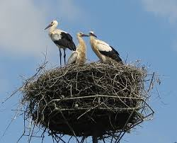](http://www.google.co.in/imgres?imgurl=http://upload.wikimedia.org/wikipedia/commons/2/2c/Ciconia_ciconia_juv_small.jpg&imgrefurl=http://en.wikipedia.org/wiki/White_stork&h=647&w=800&tbnid=yc-UeNbzNt28mM:&zoom=1&docid=zIg65CzfGYvCOM&itg=1&ei=fKyiU97HGcecugS6jYLgAw&tbm=isch&ved=0CF4QMyg7MDs)

[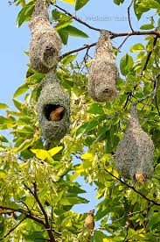](http://www.google.co.in/imgres?imgurl=https://c1.staticflickr.com/9/8017/7291405096_05ac908296_z.jpg&imgrefurl=https://www.flickr.com/photos/opyadav/7291405096/&h=640&w=424&tbnid=cnRC6xJ0qoSJbM:&zoom=1&docid=c1goilbTaNVk1M&ei=fKyiU97HGcecugS6jYLgAw&tbm=isch&ved=0CF8QMyg8MDw)

[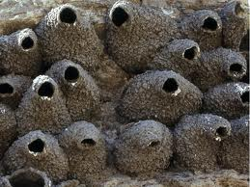](http://www.google.co.in/imgres?imgurl=http://2.bp.blogspot.com/-mPHPyNU3Xrs/Tr_6_X03lMI/AAAAAAAAASQ/4aBBANx2zbQ/s1600/mudnest.jpg&imgrefurl=http://wavesbp.blogspot.com/&h=480&w=640&tbnid=dEXHLUEBh6V0zM:&zoom=1&docid=55JvZu9ogJLmDM&ei=fKyiU97HGcecugS6jYLgAw&tbm=isch&ved=0CGAQMyg9MD0)

[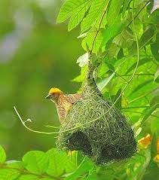](http://www.google.co.in/imgres?imgurl=http://4.bp.blogspot.com/-t0nWLsF6GCQ/TjgrhjnxYnI/AAAAAAAAATE/Foc_OhaEvEc/s1600/Beautiful-birds-nests-photo-pictures-wallpapers-images-1.jpg&imgrefurl=http://ajabgajabphotos.blogspot.com/2011/08/birds-nests-photos-pictures-wallpapers.html&h=400&w=352&tbnid=LhzThZzl2mO6HM:&zoom=1&docid=_8wFhGwe_Ypq3M&ei=fKyiU97HGcecugS6jYLgAw&tbm=isch&ved=0CGEQMyg-MD4)

[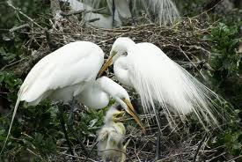](http://www.google.co.in/imgres?imgurl=http://upload.wikimedia.org/wikipedia/commons/b/b6/Ardea_alba_-St_Augustine_Alligator_Farm_Zoological_Park,_USA_-nest-8.jpg&imgrefurl=http://en.wikipedia.org/wiki/Plume_hunting&h=685&w=1024&tbnid=whDkcrP-2O5McM:&zoom=1&docid=vki5Z3CqH7FpNM&ei=fKyiU97HGcecugS6jYLgAw&tbm=isch&ved=0CGIQMyg_MD8)

[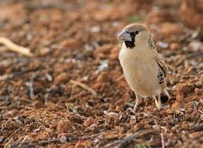](http://www.google.co.in/imgres?imgurl=http://newswatch.nationalgeographic.com/files/2012/12/Sociable-Weaver-John-Murray-950x692.jpg&imgrefurl=http://newswatch.nationalgeographic.com/2012/12/20/top-25-wild-bird-photographs-of-the-week-32/sociable-weaver-john-murray/&h=692&w=950&tbnid=PY_vwpYZaJ8tyM:&zoom=1&docid=oEQ8eK7-rGSfpM&ei=fKyiU97HGcecugS6jYLgAw&tbm=isch&ved=0CGMQMyhAMEA)

[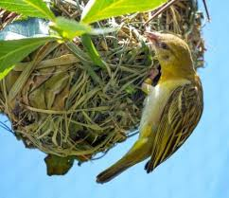](http://www.google.co.in/imgres?imgurl=http://www.mathasrilanka.com/wp-content/uploads/2013/07/14930110-weaver-bird-or-weaver-finch-ploceidae-on-grass-ball-nest-weaver-birds-get-their-names-from-the-elabo.jpg&imgrefurl=http://www.mathasrilanka.net/&h=1038&w=1203&tbnid=jgbpZnVL4LnzkM:&zoom=1&docid=dxofiGZCtKi7eM&ei=fKyiU97HGcecugS6jYLgAw&tbm=isch&ved=0CGQQMyhBMEE)

[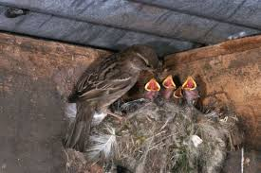](http://www.google.co.in/imgres?imgurl=http://i.dailymail.co.uk/i/pix/2012/12/05/article-0-165BC710000005DC-563_634x423.jpg&imgrefurl=http://www.dailymail.co.uk/sciencetech/article-2243295/Marlboro-palace-Researchers-finds-urban-birds-feathering-nests-cigarette-butts.html&h=423&w=634&tbnid=UYxrhEaKPXtA-M:&zoom=1&docid=zxh9hHKWaB2pFM&ei=fKyiU97HGcecugS6jYLgAw&tbm=isch&ved=0CGUQMyhCMEI)

[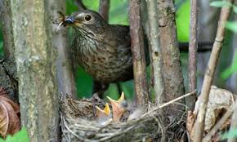](http://www.google.co.in/imgres?imgurl=http://static.guim.co.uk/sys-images/Environment/Pix/columnists/2013/6/24/1372091959337/Country-Diary---Blackbird-008.jpg&imgrefurl=http://www.theguardian.com/environment/2013/jun/27/south-uist-blackbirds-nestbuilding-early&h=276&w=460&tbnid=jAns9Gu6HCoWbM:&zoom=1&docid=zCgxGvPM9HP7jM&ei=fKyiU97HGcecugS6jYLgAw&tbm=isch&ved=0CGYQMyhDMEM)

[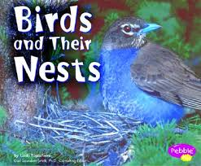](http://www.google.co.in/imgres?imgurl=http://images.betterworldbooks.com/073/Birds-and-Their-Nests-9780736823838.jpg&imgrefurl=http://www.betterworldbooks.com/birds-and-their-nests-id-0736823832.aspx&h=330&w=400&tbnid=GmOAZyjyAZOyZM:&zoom=1&docid=Xd-BCp8RuO_6KM&ei=fKyiU97HGcecugS6jYLgAw&tbm=isch&ved=0CGcQMyhEMEQ)

[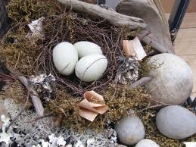](http://www.google.co.in/imgres?imgurl=http://2.bp.blogspot.com/-hlL8WyKp2fY/TXa6vYEYwlI/AAAAAAAABQc/dr08PCM7XuU/s1600/birdnest4.jpg&imgrefurl=http://donnawatsonart.blogspot.com/2011_03_01_archive.html&h=1200&w=1600&tbnid=9e9m-T07V2L4TM:&zoom=1&docid=6zH3GshP8hgnfM&ei=fKyiU97HGcecugS6jYLgAw&tbm=isch&ved=0CGgQMyhFMEU)

[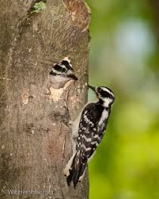](http://www.google.co.in/imgres?imgurl=http://riverparkfriends.files.wordpress.com/2013/01/downy-woodpecker-nest_wh_wil6437.jpg&imgrefurl=http://riverparkfriends.wordpress.com/category/uncategorized/&h=563&w=450&tbnid=88Yb8-rA4E3juM:&zoom=1&docid=llQh0gy1tHoOSM&ei=fKyiU97HGcecugS6jYLgAw&tbm=isch&ved=0CGkQMyhGMEY)

[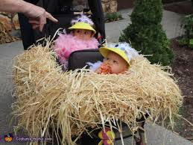](http://www.google.co.in/imgres?imgurl=http://photos.costume-works.com/full/baby_birds_in_their_nest.jpg&imgrefurl=http://www.costume-works.com/baby_birds_in_their_nest.html&h=381&w=508&tbnid=i03JEoCWxO0HJM:&zoom=1&docid=W0_uaD75m0ERnM&ei=fKyiU97HGcecugS6jYLgAw&tbm=isch&ved=0CGoQMyhHMEc)

[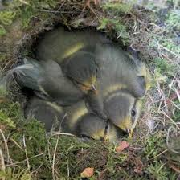](http://www.google.co.in/imgres?imgurl=http://cdn2.belfasttelegraph.co.uk/migration_catalog/article28989054.ece/96c66/ALTERNATES/h342/Strange%252BBut%252BTrue%252B5-1.jpg&imgrefurl=http://www.belfasttelegraph.co.uk/breakingnews/offbeat/birds-light-upon-butts-nest-lining-29001603.html&h=342&w=342&tbnid=CIyOh4sxiEOEeM:&zoom=1&docid=Gdp_0LiGPm7h4M&ei=fKyiU97HGcecugS6jYLgAw&tbm=isch&ved=0CGsQMyhIMEg)

[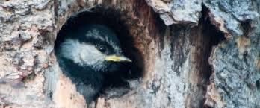](http://www.google.co.in/imgres?imgurl=http://10000birds.com/wp-content/uploads/2012/07/MOCHnestling600X06282009.jpg&imgrefurl=http://10000birds.com/cavity-nesting-birds-of-north-america-and-their-babies.htm&h=250&w=600&tbnid=3rLLQaZSMieAhM:&zoom=1&docid=3fAP4pUUA6JFpM&ei=fKyiU97HGcecugS6jYLgAw&tbm=isch&ved=0CGwQMyhJMEk)

[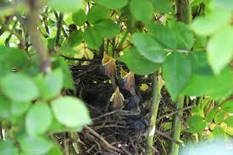](http://www.google.co.in/imgres?imgurl=http://4.bp.blogspot.com/-VvbmKDDXeiE/UZu060BYZ8I/AAAAAAAAz40/EIQjMoV_fc0/s1600/IMG_3037.JPG&imgrefurl=http://withoutlovewehavenothing.blogspot.com/2013/05/birds-in-their-little-nest-agree.html&h=1067&w=1600&tbnid=xp-cw1A3Ao0J5M:&zoom=1&docid=O1cQYtkHs_ZAxM&ei=fKyiU97HGcecugS6jYLgAw&tbm=isch&ved=0CG0QMyhKMEo)

[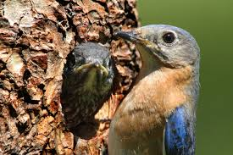](http://www.google.co.in/imgres?imgurl=http://4.bp.blogspot.com/-PwoIJsOIbxU/TaXgWMWtvEI/AAAAAAAABAg/vDoLFIzzE-0/s1600/E%252BBluebirds%252BS%252BByland%252B-%252B1321.JPG&imgrefurl=http://stevebyland.blogspot.com/2011/04/build-natural-cavity-bird-house.html&h=444&w=666&tbnid=viwmuzq9LK-PhM:&zoom=1&docid=R9FeRe4h9e4DWM&ei=fKyiU97HGcecugS6jYLgAw&tbm=isch&ved=0CG4QMyhLMEs)

[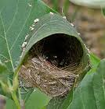](http://www.google.co.in/imgres?imgurl=http://en.harunyahya.net/resimleri/sites/4/23/the-interesting-nests-of-birds.jpg&imgrefurl=http://en.harunyahya.net/the-interesting-nests-of-birds/&h=176&w=168&tbnid=WdIvcLzu3uUVqM:&zoom=1&docid=p7CEcHYQ_Cmo-M&ei=fKyiU97HGcecugS6jYLgAw&tbm=isch&ved=0CG8QMyhMMEw)

[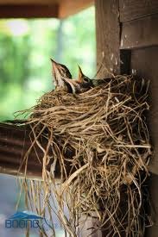](http://www.google.co.in/imgres?imgurl=http://boonerealestate.com/wp-content/uploads/2012/06/120526BirdsNestBooneNC-0112.jpg&imgrefurl=http://boonerealestate.com/adorable-robin-fledglings-in-their-nest/&h=900&w=600&tbnid=5QiNWY_91O8yQM:&zoom=1&docid=jNzFDw_3JjBhFM&ei=fKyiU97HGcecugS6jYLgAw&tbm=isch&ved=0CHAQMyhNME0)

[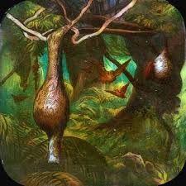](http://www.google.co.in/imgres?imgurl=http://a-day-in-the-life.powys.org.uk/images/u_primus723-3.jpg&imgrefurl=http://a-day-in-the-life.powys.org.uk/eng/cult/magiclan/eu_723.php&h=322&w=322&tbnid=_B0KMWPBqRs99M:&zoom=1&docid=Zei6-V7qlX8VhM&ei=fKyiU97HGcecugS6jYLgAw&tbm=isch&ved=0CHEQMyhOME4)

[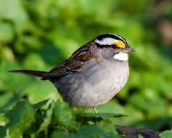](http://www.google.co.in/imgres?imgurl=http://www.ec.gc.ca/paom-itmb/7800177F-1C73-47CF-B86C-790F2DE04E12/0010-WTS.jpg&imgrefurl=http://www.ec.gc.ca/paom-itmb/default.asp?lang%3DEn%26n%3D7800177F-1&h=242&w=300&tbnid=mO8k8-MbsWXvYM:&zoom=1&docid=EfHEPkg9czjvyM&ei=fKyiU97HGcecugS6jYLgAw&tbm=isch&ved=0CHIQMyhPME8)

[](http://www.google.co.in/imgres?imgurl=http://nintendookie.files.wordpress.com/2012/02/lucky-birds-title-screen.jpg&imgrefurl=http://nintendo-okie.com/2012/02/17/lucky-birds-city-review-ios/&h=400&w=267&tbnid=uQ6mDwXypE-_vM:&zoom=1&docid=DndM1thepmo9lM&ei=fKyiU97HGcecugS6jYLgAw&tbm=isch&ved=0CHMQMyhQMFA)

[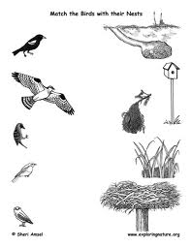](http://www.google.co.in/imgres?imgurl=http://www.exploringnature.org/graphics/matching_bird_home72.jpg&imgrefurl=http://www.exploringnature.org/db/detail.php?dbID%3D45%26detID%3D2845&h=792&w=612&tbnid=11aCZXhghLmo6M:&zoom=1&docid=vJ08QCY4iIovbM&ei=fKyiU97HGcecugS6jYLgAw&tbm=isch&ved=0CHQQMyhRMFE)

[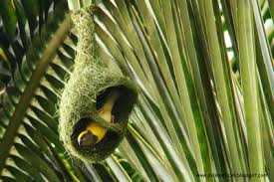](http://www.google.co.in/imgres?imgurl=http://3.bp.blogspot.com/_R_Hu94sw2D0/TTYi1Vf_BGI/AAAAAAAAABI/KuOJTc9bfrA/s1600/weaver%2525252Bbird.jpg&imgrefurl=http://makingofthesilentstars.blogspot.com/2011/01/bird-nests-make-me-smile-they-do.html&h=267&w=400&tbnid=iTRq1swIObkXUM:&zoom=1&docid=OM-O7cGtydy_UM&ei=fKyiU97HGcecugS6jYLgAw&tbm=isch&ved=0CHUQMyhSMFI)

[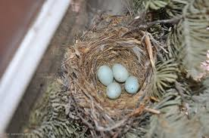](http://www.google.co.in/imgres?imgurl=http://4.bp.blogspot.com/-mXqPH-23e3k/UWt5umzCNSI/AAAAAAAAGlw/pyPRW9DQct0/s1600/nest.jpg&imgrefurl=http://www.thegardenroofcoop.com/2013/04/april-2013.html&h=855&w=1287&tbnid=hZFvgRep9vEKSM:&zoom=1&docid=DV5ZxruEbLWCqM&ei=fKyiU97HGcecugS6jYLgAw&tbm=isch&ved=0CHYQMyhTMFM)

[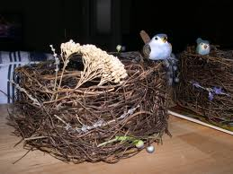](http://www.google.co.in/imgres?imgurl=http://www.bridalbuds.com/wp-content/uploads/brids-nest-wedding-centerpiece.jpg&imgrefurl=http://www.bridalbuds.com/2009/06/most-painful-centerpieces-ever/&h=1704&w=2272&tbnid=-QJAufEHf8w2cM:&zoom=1&docid=DxUiCRHDWcpkFM&ei=fKyiU97HGcecugS6jYLgAw&tbm=isch&ved=0CHcQMyhUMFQ)

[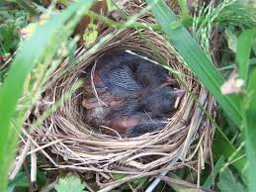](http://www.google.co.in/imgres?imgurl=http://i863.photobucket.com/albums/ab197/jake23ts/100_9281.jpg&imgrefurl=http://www.arachnoboards.com/ab/showthread.php?188767-Baby-birds-in-their-nest.&h=768&w=1024&tbnid=Sq9tUHX0slHhWM:&zoom=1&docid=K07vp2DEiwsuJM&ei=fKyiU97HGcecugS6jYLgAw&tbm=isch&ved=0CHgQMyhVMFU)

[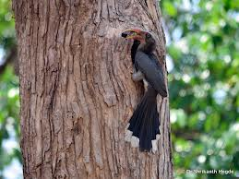](http://www.google.co.in/imgres?imgurl=http://2.bp.blogspot.com/-B-amE8AOJZQ/T4xzrI4k29I/AAAAAAAAFtQ/Y2J7OLIXktE/s1600/DSC_6851.JPG&imgrefurl=http://snhegde.blogspot.com/&h=1200&w=1600&tbnid=JmK4x7tulV2xlM:&zoom=1&docid=swPbhiu4vyz9EM&ei=fKyiU97HGcecugS6jYLgAw&tbm=isch&ved=0CHkQMyhWMFY)

[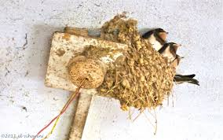](http://www.google.co.in/imgres?imgurl=http://enjoyingindia.com/wp-content/uploads/2011/06/swallow-chicks1.jpg&imgrefurl=http://enjoyingindia.com/2011/06/19/birds-of-fortune/&h=2227&w=3557&tbnid=Okvw9cv4f3B_NM:&zoom=1&docid=x515nBSgsMUbZM&ei=fKyiU97HGcecugS6jYLgAw&tbm=isch&ved=0CHoQMyhXMFc)

[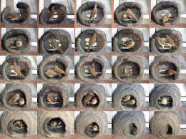](http://www.google.co.in/imgres?imgurl=http://www.raafatrola.com/wp-content/uploads/2013/11/making-a-nest.jpg&imgrefurl=http://www.raafatrola.com/birds-making-their-nest/&h=537&w=720&tbnid=ycJIjWGif1-esM:&zoom=1&docid=pfqvMzcU433foM&ei=fKyiU97HGcecugS6jYLgAw&tbm=isch&ved=0CHsQMyhYMFg)

[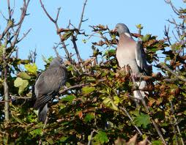](http://www.google.co.in/imgres?imgurl=http://4.bp.blogspot.com/_0YOjaotiavQ/TIfXByyvTTI/AAAAAAAAK1o/S9Sf1n_tGoo/s1600/pigeons.jpg&imgrefurl=http://kingsdownkent.blogspot.com/2010/09/another-invader.html&h=1251&w=1600&tbnid=Y0ctlxIzXS0AzM:&zoom=1&docid=Vd65J-AC5yPq2M&ei=fKyiU97HGcecugS6jYLgAw&tbm=isch&ved=0CHwQMyhZMFk)

[](http://www.google.co.in/imgres?imgurl=http://images.nintendolife.com/news/2010/08/angry_birds_making_their_nest_on_wiiware/large.jpg&imgrefurl=http://www.nintendolife.com/news/2010/08/angry_birds_making_their_nest_on_wiiware&h=319&w=480&tbnid=aJbQ9V9MQ9ul9M:&zoom=1&docid=jycY-jPDRNPhzM&ei=fKyiU97HGcecugS6jYLgAw&tbm=isch&ved=0CH0QMyhaMFo)

[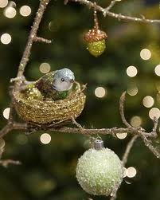](http://www.google.co.in/imgres?imgurl=http://themagicbean.typepad.com/.a/6a00d834fe9c4653ef014e8bad37a8970d-320wi&imgrefurl=http://themagicbean.typepad.com/the_magic_bean/2011/11/freebie-friday-free-bird-patterns-and-tutorials.html&h=400&w=320&tbnid=vNwzzHugxzsyiM:&zoom=1&docid=P766lvRSXo8u9M&ei=fKyiU97HGcecugS6jYLgAw&tbm=isch&ved=0CH4QMyhbMFs)

[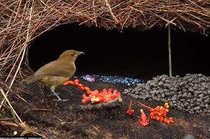](http://www.google.co.in/imgres?imgurl=http://www.strangeclosets.com/wp-content/uploads/2011/01/bowerbird-825x550-600x400.jpg&imgrefurl=http://www.strangeclosets.com/2011/01/birds-and-decor/&h=400&w=600&tbnid=XrdEyGcGTNwwpM:&zoom=1&docid=0-ozqqSi2neflM&ei=fKyiU97HGcecugS6jYLgAw&tbm=isch&ved=0CH8QMyhcMFw)

[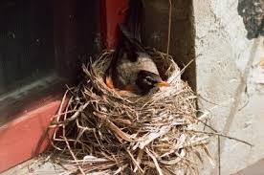](http://www.google.co.in/imgres?imgurl=http://gardenersblog.jerseyplantsdirect.com/wp-content/uploads/2012/02/different-types-bird-nests-800X800.jpg&imgrefurl=http://gardenersblog.jerseyplantsdirect.com/?p%3D5317&h=265&w=400&tbnid=J2g-3B0YteywQM:&zoom=1&docid=RIl6AwBCQUN-iM&ei=fKyiU97HGcecugS6jYLgAw&tbm=isch&ved=0CIABEDMoXTBd)

[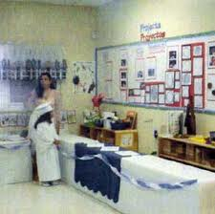](http://www.google.co.in/imgres?imgurl=http://ecrp.uiuc.edu/figures/v8n1-elizondo/figure30.jpg&imgrefurl=http://ecrp.uiuc.edu/v8n1/elizondo.html&h=348&w=350&tbnid=kAtE0YJ3vsPpbM:&zoom=1&docid=matw8ucrpOCrkM&ei=fKyiU97HGcecugS6jYLgAw&tbm=isch&ved=0CIEBEDMoXjBe)

[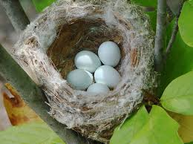](http://www.google.co.in/imgres?imgurl=http://2.bp.blogspot.com/-MTY71J2U_Ck/UA76g7_aLsI/AAAAAAAAB8Y/9vVHbc70Gu8/s1600/Nest%252Bof%252BGoldfinch.jpg&imgrefurl=http://tlcforscc.blogspot.com/2012/07/nesting-birds-in-july.html&h=478&w=640&tbnid=5tEobH9eKAeY5M:&zoom=1&docid=EGOBVivb9B9P8M&ei=fKyiU97HGcecugS6jYLgAw&tbm=isch&ved=0CIIBEDMoXzBf)

[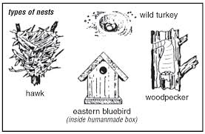](http://www.google.co.in/imgres?imgurl=http://www.inhs.illinois.edu/resources/virtualbird/teacher/images/L5nests.jpg&imgrefurl=http://www.inhs.illinois.edu/resources/virtualbird/teacher/lespl5.html&h=685&w=1043&tbnid=D8BFI5TK22kEQM:&zoom=1&docid=v-fueHIRvpmcFM&ei=fKyiU97HGcecugS6jYLgAw&tbm=isch&ved=0CIMBEDMoYDBg)

[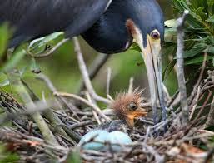](http://www.google.co.in/imgres?imgurl=http://sar-cdn.com/sites/default/files/imagecache/superphoto/W%252520062411%252520Birds%25252001.jpg&imgrefurl=http://staugustine.com/news/local-news/2011-06-25/birds-feather-hatching-together&h=458&w=600&tbnid=dSpcgcai1HQ6fM:&zoom=1&docid=54Hz1f2OfF6UhM&ei=fKyiU97HGcecugS6jYLgAw&tbm=isch&ved=0CIQBEDMoYTBh)

[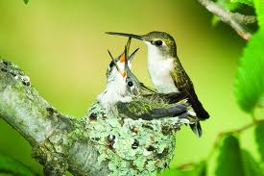](http://www.google.co.in/imgres?imgurl=http://3.bp.blogspot.com/-tlBmQ-k59DI/T5mPIgbchuI/AAAAAAAAFow/ra0qDPf7Lug/s1600/Baby%252BRuby-throated%252Bhummingbird.jpg&imgrefurl=http://lansingwbu.blogspot.com/2014/04/where-ruby-throated-hummingbirds-nest.html&h=427&w=640&tbnid=sCagAfRXUUm0OM:&zoom=1&docid=QsOL-FHjMauocM&ei=fKyiU97HGcecugS6jYLgAw&tbm=isch&ved=0CIUBEDMoYjBi)

[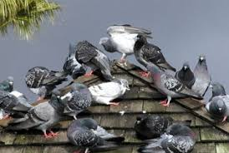](http://www.google.co.in/imgres?imgurl=http://www.nachi.org/images09/pest.jpg&imgrefurl=http://www.nachi.org/pest-birds-commercial-property.htm&h=311&w=463&tbnid=IdYTOaB4WdbKQM:&zoom=1&docid=Yy-J1ynm1qAUvM&ei=fKyiU97HGcecugS6jYLgAw&tbm=isch&ved=0CIYBEDMoYzBj)

[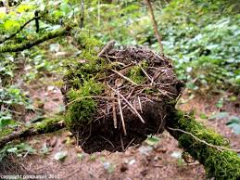](http://www.google.co.in/imgres?imgurl=http://2.bp.blogspot.com/_RIDIKSRK_bI/TF0RDZI5HRI/AAAAAAAABPg/itdoXxdBeOs/s1600/nest-fa.jpg&imgrefurl=http://pnwnature.blogspot.com/2010/08/birds-nests.html&h=433&w=577&tbnid=cl7KW2oX9DYnJM:&zoom=1&docid=9pG1ujMbyom7uM&ei=oayiU4uOOMiVuATiy4L4Aw&tbm=isch&ved=0CAgQMygAMAA4ZA)

[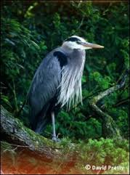](http://www.google.co.in/imgres?imgurl=http://www.wildlifetree.ca/images/henry300.jpg&imgrefurl=http://www.wildlifetree.ca/birds.html&h=302&w=224&tbnid=yJlJ3rt-rJ-XpM:&zoom=1&docid=BuC3uWWwnZFIeM&ei=oayiU4uOOMiVuATiy4L4Aw&tbm=isch&ved=0CAkQMygBMAE4ZA)

[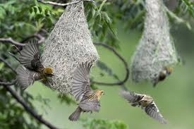](http://www.google.co.in/imgres?imgurl=http://www.brecorder.com/images/pic2012/06/caption21_1.jpg&imgrefurl=http://www.brecorder.com/picture-of-the-day/63472-kathmandu-weaver-birds-flutter-near-their-nests-hanging-from-a-tree-in-kathmandu-on-june-21-2012-weavers-small-passerine-birds-related-to-finches-are-one-of-some-868-species-of-birds-found-in-nepal-the-countrys-diverse-topography-and-climate-is-hom.html&h=267&w=400&tbnid=Ll2PGkPujmFtyM:&zoom=1&docid=roqzTUyIqmH6LM&ei=oayiU4uOOMiVuATiy4L4Aw&tbm=isch&ved=0CAoQMygCMAI4ZA)

[[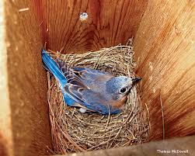](http://www.google.co.in/imgres?imgurl=http%3A%2F%2Fwww.nwf.org%2F~%2Fmedia%2FContent%2FNWM%2FBirds%2FBluebirdinNestbox_ThomasMcDowell_570x457.ashx&imgrefurl=http%3A%2F%2Fwww.nwf.org%2FNews-and-Magazines%2FNational-Wildlife%2FBirds%2FArchives%2F2012%2FSchoolyard-Bluebird-Boxes.aspx&h=457&w=570&tbnid=TQsuFNLjUrviRM%3A&zoom=1&docid=0xH8WVsjlnjjEM&ei=oayiU4uOOMiVuATiy4L4Aw&tbm=isch&ved=0CAsQMygDMAM4ZA&iact=rc&uact=3&dur=0&page=5&start=88&ndsp=23)](http://www.google.co.in/imgres?imgurl=http%3A%2F%2Fwww.nwf.org%2F~%2Fmedia%2FContent%2FNWM%2FBirds%2FBluebirdinNestbox_ThomasMcDowell_570x457.ashx&imgrefurl=http%3A%2F%2Fwww.nwf.org%2FNews-and-Magazines%2FNational-Wildlife%2FBirds%2FArchives%2F2012%2FSchoolyard-Bluebird-Boxes.aspx&h=457&w=570&tbnid=TQsuFNLjUrviRM%3A&zoom=1&docid=0xH8WVsjlnjjEM&ei=oayiU4uOOMiVuATiy4L4Aw&tbm=isch&ved=0CAsQMygDMAM4ZA&iact=rc&uact=3&dur=0&page=5&start=88&ndsp=23)

[570 × 457 - nwf.org](http://www.google.co.in/imgres?imgurl=http%3A%2F%2Fwww.nwf.org%2F~%2Fmedia%2FContent%2FNWM%2FBirds%2FBluebirdinNestbox_ThomasMcDowell_570x457.ashx&imgrefurl=http%3A%2F%2Fwww.nwf.org%2FNews-and-Magazines%2FNational-Wildlife%2FBirds%2FArchives%2F2012%2FSchoolyard-Bluebird-Boxes.aspx&h=457&w=570&tbnid=TQsuFNLjUrviRM%3A&zoom=1&docid=0xH8WVsjlnjjEM&ei=oayiU4uOOMiVuATiy4L4Aw&tbm=isch&ved=0CAsQMygDMAM4ZA&iact=rc&uact=3&dur=0&page=5&start=88&ndsp=23)

[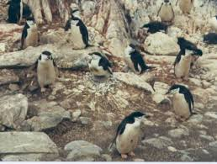](http://www.google.co.in/imgres?imgurl=http://www.communigate.co.uk/ne/penguins/phpdXBHJH&imgrefurl=http://www.keywordpicture.com/keyword/birds%2520and%2520their%2520nests/&h=340&w=450&tbnid=2fAMz8fVvaCuSM:&zoom=1&docid=vo-4oYw_-CtzOM&ei=oayiU4uOOMiVuATiy4L4Aw&tbm=isch&ved=0CAwQMygEMAQ4ZA)

[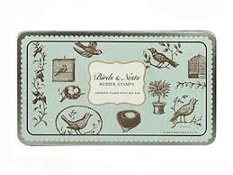](http://www.google.co.in/imgres?imgurl=http://www.littleowl.bg/uploads/images/product_images/product_thumbs/Rubber%252520Stamps%252520Birds%252520and%252520Nests%252520Cavallini%252520and%252520Co%252520M_5986.jpg&imgrefurl=http://www.littleowl.bg/en/product/Play-Big/Beautiful-Stamps-%2522Birds-and-their-Nests%2522-in-a-tin-box.html&h=375&w=500&tbnid=eHi5sqyJzmGiIM:&zoom=1&docid=cNipTEDSMmiqLM&ei=oayiU4uOOMiVuATiy4L4Aw&tbm=isch&ved=0CA0QMygFMAU4ZA)

[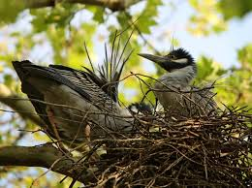](http://www.google.co.in/imgres?imgurl=http://2.bp.blogspot.com/-WaUu4Owd7tQ/UYxM5bF944I/AAAAAAAANQg/M1MqK7KFKmA/s1600/5%252BYellow-crowned%252BNight-Heron%2525252C%252BFranklin%252BCo.%2525252C%252BOH%252BMay%252B9%2525252C%252B2013%252B%2525252849%25252529.JPG&imgrefurl=http://jimmccormac.blogspot.com/2013/05/bexleys-famous-night-herons.html&h=764&w=1024&tbnid=uPh_ILYw4S6RxM:&zoom=1&docid=M3T0V7aVkeDhVM&ei=oayiU4uOOMiVuATiy4L4Aw&tbm=isch&ved=0CA4QMygGMAY4ZA)

[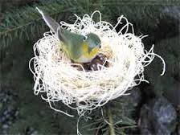](http://www.google.co.in/imgres?imgurl=http://www.runnerduck.com/images/birds_nest.jpg&imgrefurl=http://www.runnerduck.com/crafts/garden_crafts/garden_crafts.htm&h=210&w=280&tbnid=b1PSj-LInj_AKM:&zoom=1&docid=1wo-o3RUAleeqM&ei=oayiU4uOOMiVuATiy4L4Aw&tbm=isch&ved=0CA8QMygHMAc4ZA)

[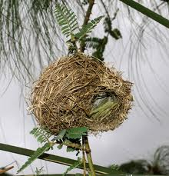](http://www.google.co.in/imgres?imgurl=https://chimpanzeeletters.files.wordpress.com/2012/06/nest-to-nest1.jpg&imgrefurl=https://chimpanzeeletters.wordpress.com/2012/06/&h=2944&w=2824&tbnid=YYDsgV05mchI8M:&zoom=1&docid=-zAUzZuHAg13dM&ei=oayiU4uOOMiVuATiy4L4Aw&tbm=isch&ved=0CBAQMygIMAg4ZA)

[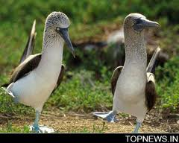](http://www.google.co.in/imgres?imgurl=http%3A%2F%2Fwww.topnews.in%2Ffiles%2FBirds-9919.jpg&imgrefurl=http%3A%2F%2Ftopnews.in%2Fbirds-learn-neighbours-how-defend-nests-2174604&h=241&w=300&tbnid=rXrAmPhJbsf6bM%3A&zoom=1&docid=i-gis-8_AXJGFM&ei=oayiU4uOOMiVuATiy4L4Aw&tbm=isch&ved=0CBEQMygJMAk4ZA&iact=rc&uact=3&dur=215&page=5&start=88&ndsp=23)

[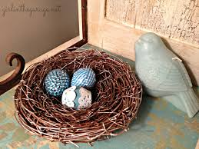](http://www.google.co.in/imgres?imgurl=http://girlinthegarage.net/wp-content/uploads/2013/02/Nest7bird.jpg&imgrefurl=http://girlinthegarage.net/2013/02/spring-things/&h=2346&w=3128&tbnid=qcW7B1TWE_tU7M:&zoom=1&docid=80t10fz4LdlWuM&ei=oayiU4uOOMiVuATiy4L4Aw&tbm=isch&ved=0CBIQMygKMAo4ZA)

[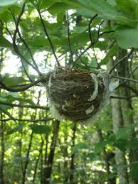](http://www.google.co.in/imgres?imgurl=http://3.bp.blogspot.com/-zIH9DqlpmFM/UA_odl07PXI/AAAAAAAAImg/zQXHJCZKpHE/s1600/unknownnest1.jpg&imgrefurl=http://theenchantedtree.blogspot.com/2012/07/baby-birds.html&h=800&w=600&tbnid=2zcXChmJ-sIudM:&zoom=1&docid=TFJEReEdMiTaLM&ei=oayiU4uOOMiVuATiy4L4Aw&tbm=isch&ved=0CBMQMygLMAs4ZA)

[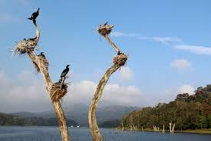](http://www.google.co.in/imgres?imgurl=https://c2.staticflickr.com/8/7173/6649982597_bb661506a8_z.jpg&imgrefurl=https://www.flickr.com/photos/31865058@N04/6649982597/&h=427&w=640&tbnid=gBcNws_8x92E9M:&zoom=1&docid=DG6dsOy2s7PP2M&ei=oayiU4uOOMiVuATiy4L4Aw&tbm=isch&ved=0CBQQMygMMAw4ZA)

[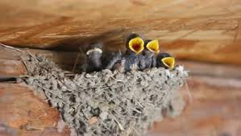](http://www.google.co.in/imgres?imgurl=http://ak5.picdn.net/shutterstock/videos/2671718/preview/stock-footage-swallow-feeding-baby-birds-in-their-nest.jpg&imgrefurl=http://www.shutterstock.com/video/clip-736804-stock-footage-bird-coot-making-its-nest-on-water.html&h=226&w=400&tbnid=K7j_VumWGpwm5M:&zoom=1&docid=4U7AULU_piQzBM&ei=oayiU4uOOMiVuATiy4L4Aw&tbm=isch&ved=0CBUQMygNMA04ZA)

[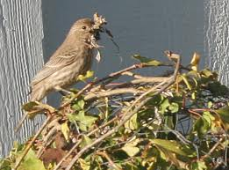](http://www.google.co.in/imgres?imgurl=http://spacewalkerthrougheternity.files.wordpress.com/2011/11/mamabird.jpg&imgrefurl=http://spacewalkerthrougheternity.wordpress.com/2011/11/14/birds-of-a-feather/&h=341&w=459&tbnid=h80Re4L948b2jM:&zoom=1&docid=c_txctbw75M66M&ei=oayiU4uOOMiVuATiy4L4Aw&tbm=isch&ved=0CBYQMygOMA44ZA)

[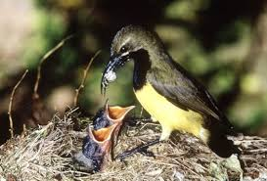](http://www.google.co.in/imgres?imgurl=http%3A%2F%2Faustralianmuseum.net.au%2FUploads%2FImages%2F1897%2Flife_34_big.jpg&imgrefurl=http%3A%2F%2Faustralianmuseum.net.au%2Fimage%2FBird-feeding-a-spider-to-chicks%2F&h=357&w=526&tbnid=O6ykmHt-k8B2iM%3A&zoom=1&docid=Q7g_0lR6i0iiWM&ei=oayiU4uOOMiVuATiy4L4Aw&tbm=isch&ved=0CBcQMygPMA84ZA&iact=rc&uact=3&dur=55&page=6&start=111&ndsp=24)

[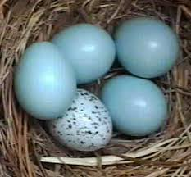](http://www.google.co.in/imgres?imgurl=http%3A%2F%2Ffatfinch.files.wordpress.com%2F2008%2F01%2Fcowbird-agg.jpg&imgrefurl=http%3A%2F%2Ffatfinch.wordpress.com%2F2008%2F01%2F03%2Fcowbirds%2F&h=384&w=415&tbnid=jw8eNMMl5GO3fM%3A&zoom=1&docid=uW3kNAmVyrGffM&ei=oayiU4uOOMiVuATiy4L4Aw&tbm=isch&ved=0CBgQMygQMBA4ZA&iact=rc&uact=3&dur=2100&page=6&start=111&ndsp=24)