1. Organize a party
Setting up a romantic dinner or planning a weekend getaway is awesome but if your parents like to be surrounded with their friends and family or have an amazing social group then what can be better than organizing a party for them. Select a romantic or even some dramatic theme, make a guest list keeping all their close ones in mind, arrange for their favourite dishes, and decorate the place the way they like and surprise! There is no way that your parents will not like the effort you would be putting in to throw a party for them.
2. Couple rings
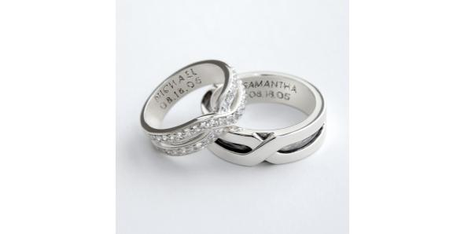
Your parents’ anniversary is a special and a precious occasion. And very few gifts can be as precious as jewelry. Gifting your parents a pair of rings can be a smart choice. Every anniversary has a certain stone linked to it, like 5th anniversaries have sapphire, 10th has diamond, 15th has ruby and so on. You can get rings with the stone analogous to their wedding year and present it to your parents. Or one can also have their names engraved on the rings just like newly-weds. They would love to wear those and will appreciate their marriage and family even more.
3. Custom Statuettes
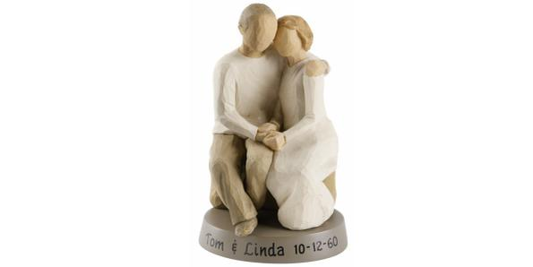
You can get your parents some customized statuettes in a variety of materials and designs. From glass crystals with imprinted messages to wooden embossing, one can find a huge collection online as well as in gifting stores. You can get one of their favourite picture printed on a glass crystal or some message printed for them in bronze or some other material. They can keep this statuette on their desk and always be reminded of their amazing wedding and wonderful kids.
4. Anniversary Journal
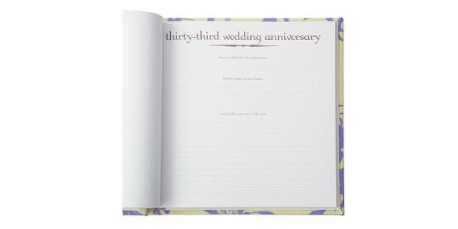
If you want to gift your parents something in which they can keep a complete record of their marriage from Day 1 then anniversary journals are your thing. These can be in form of a book with a hardcover having enough pages that your parents can use it till their 50th anniversary or even more. They can add pictures or write about little instances they encountered every year together. The journal will timeline their beautiful moments and how far they have come as a couple. You can present a blank journal for your parents to fill up on their own or you can fill up the pages for the years which they have already passed. Your parents are surely going to love this gift.
5. Set up a date
We all know that once a couple become parents their lives take a 360 degree turn. The love and romance somewhere gets side-lined due to bringing up of children and the responsibilities attached with that. So, on this anniversary you can give them another chance to feel all the love that they have for each other by setting up a date for them. You can book them a table in a classy restaurant or buy them a couple of tickets for a romantic destination they have been longing to visit. After all it’s their day and the most important thing is for them to celebrate it together.

